Drum Major & Section Leader
Audition Process

Step 1:
- Fill out the Application ONLINE and submit to Mrs. Boates by May 30, 2014
plattband.weebly.com/band-leadership.html

Day(s) of Audition

Step 2: Verbal Commands (drum major applicants only)
- Drum Major candidates will take turns giving vocal directions outside to the other candidates (plus a few volunteers) who will be marching.
- Stand at attention with good posture. Remember you are presenting yourself as the representative of The Platt Band: look and sound confident. Make each command sound like it counts.
- When calling commands, support your voice the way you would an instrument. Breathe deeply and use plenty of air.
  - It may feel silly yelling commands at home, out of context, but practicing this is the best way to prepare for the auditions.
  - Commands including, but not limited to: Attention, Parade Rest, Mark Time, Halt,
- BE LOUD! But also remember to be crisp and understandable. Just make sure that you are not sacrificing your understandability for volume.

Step 3: Marching (all candidates)
- You will be taking turns on the receiving end of the vocal commands.
  - Commands including, but not limited to: Marking time, flanks, turns, forward & backward marching, stopping and starting
- Keep careful attention to your footwork, posture, and rigidness.
- Remember that Drum Majors need to be the best example of marching technique.

Step 4: Conducting (all candidates)
- You will conduct and rehearse a piece chosen by Mrs. Boates.
  - Practice in a mirror.
  - Practice with a metronome.
  - Make sure ALL beats are clear.
  - Listen for things that need to be improved and do your best to address them.
  - Work with the current Drum Major and/or Mrs. Boates to prepare your conducting.

Drum Major Responsibilities:

The most important position in the marching band is that of the drum major. This person is the leader on the field. The drum major exemplifies the spirit, dignity, and bearing of the entire band, and therefore should possess these qualities to the highest degree.
Duties of the Drum Major include, but are not limited to:

A. Marching Rehearsals
1. Arrives early to all rehearsals setting the example.
2. Consults with directors prior to each rehearsal for instructions concerning the rehearsal plan.
3. Leads the band through the warm-up routine, both playing and marching.
4. Assists director in the teaching of marching drills.
5. Help individual band members with difficult sections of the drill when problems arise.
6. Learns and understands drill in order to assist where needed.
7. Acts as a monitor of focus for the band in order to make rehearsals run as efficiently as possible.
8. Meet with the director before leaving to debrief rehearsal and developing a plan for the next day.

B. Music Rehearsals
1. Arrive early to all rehearsals setting the example.
2. Consult with the director prior to each rehearsal and make every attempt to be thoroughly acquainted with all aspects of the music to be rehearsed, including conducting techniques and possible problems that may be encountered in rehearsal or performance.
3. Lead the band through preliminary warm-up routines.
4. Be prepared to take charge of specific groups for sectional rehearsals.
5. Meet with the director before leaving to debrief rehearsal and developing a plan for the next day.

C. Performance
1. Arrive early - setting the example.
2. Take responsibility for making sure the band is assembled in the proper formation at the pre-designated time and place.
3. Assist with general inspection of uniforms.
4. Be responsible for moving the band from one area to the next in an orderly manner.
5. At football games, make sure band is in pre-determined formation in stands and that order is maintained.
6. Conduct the band when they play pep tunes in the stands or at pep rallies.
7. Take attendance after third quarter to make sure everyone is back and ready to play.
8. Prior to a parade, become familiar with the parade route and be aware of the location of the reviewing stand.
9. Know when to bring the band and auxiliary units to attention.
10. Give all commands during performances.
11. Set the example at all times in dress, leadership, punctuality, alertness, precise marching, & esprit de corps.

D. Other
1. Strong dedication to the band program.
2. Always ready to do what’s best for the band – even if it’s not what you want.
3. Liaison between the band and the director.
4. Exhibit a great attitude and encourage good morale within the band.
5. Be enthusiastic & positive.
Desirable Qualities of a Drum Major:

- Candidate should possess a good personality, present “positivity” and should get along well with others.
- The individual should be intelligent, and should have the capability to think quickly under pressure.
- A strong dedication to the band program by the individual is vital.
- The individual’s musical ability should be of the highest level.
- The candidate should possess a good personality and should get along well with others.
- Candidate should be very dependable.
- Exhibiting a good attitude and encouraging good morale within the band is a major responsibility of the Drum Major.
- The Drum Major must be enthusiastic in his/her dealings with the band.

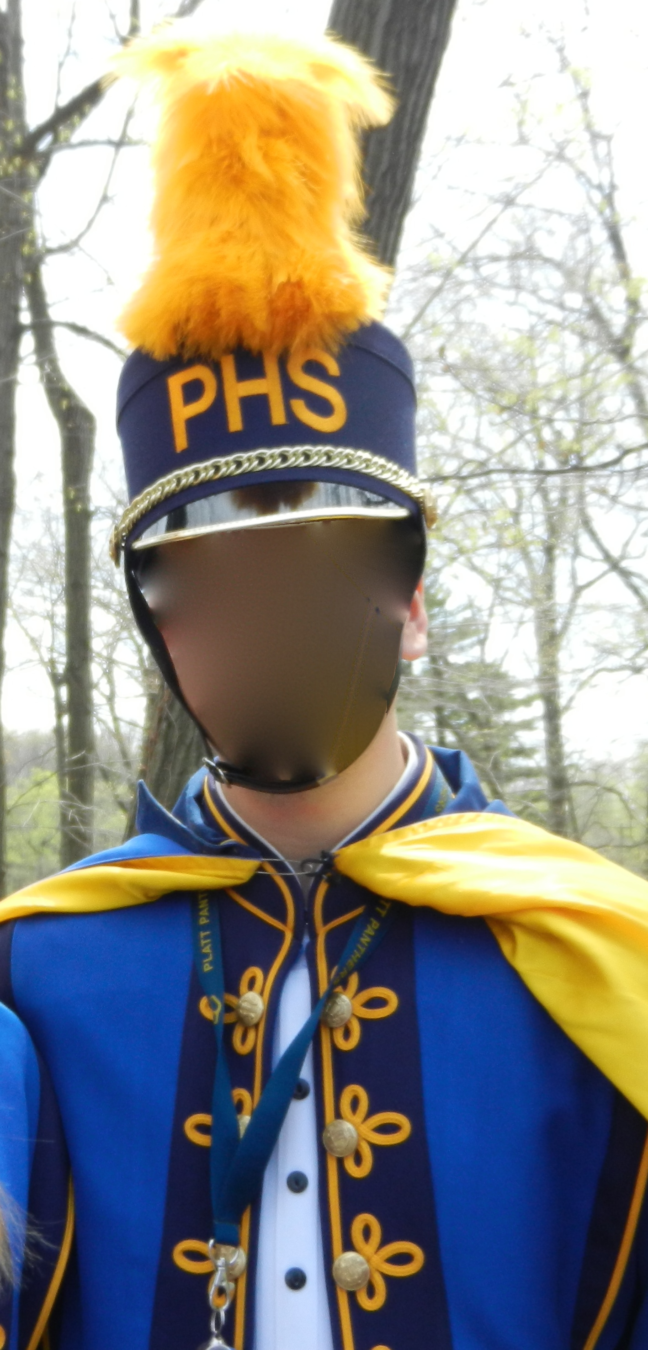

YOU!?!

WILL THIS BE YOU!
Section Leader Responsibilities:

- BE A ROLE MODEL– The band will follow the example you set. This should be your #1 priority.
  - Come to every rehearsal prepared.
  - Always be prepared to carry out your duties.
  - Respect all band members whether you like them or not.
  - Be early to all rehearsals and performances.
  - People remember how you act more than how you perform.
  - A role model is much more powerful than words.
  - You are a direct link between staff and band members.
  - Display the most positive attitude possible.
- You have a responsibility to help your section and the band in general to be successful.
- Constantly monitor your section. Take control of situations. You have the ability to make rehearsals run efficiently.
  - Keep people quiet in line and on the field.
  - Check on memorization of music.
  - Assist people who did not come to sectionals/rehearsals.
  - Uniform inspection before performance. Fix it or alert the staff about it.
- You are a teacher of your peers. Any situations involving grades or participation must be handle by a staff member.
- Discuss problem situations in private on an individual basis, not in front of your section. Wait until after rehearsal; don’t interrupt someone else’s rehearsal.
- Remember: a group is only as strong as its weakest link. Your goal is to help every member (including yourself) to become stronger.
- It takes less time to do something than to stand around and discuss it; you’ll have to do it anyway!
- Strive for the best possible sound.
- Strive for accuracy in marching and maneuvering.
- Eliminate visual errors.
- Maximize rehearsal time.
- Strive for clean execution and performance, both musically and visually.

2014 Platt High School Band
Student Leader Tryout Sheet

Name: _________________________
Marching
___10 pt. Stride—Carriage
___ 5 pt. Roll Step
___ 5 pt. Following Commands
___Sub Total

Vocal Commands—20 points
____5 pts. Steady Beat While Giving Commands
____5 pts. Vocal Strength
____5 pts. Vocal Clarity
____5 pts. Timeliness of Commands Given
_____Sub Total

Conducting Rehearsal
____5 pts. Prepared to Address a Specific Musical Issue
____10 pts. Presence with Band
____10 pts. Conducting Pattern is Clear
____20 pts. Able to find and address problems as they occur.
______Sub Total

Grand Total_________________

